EW – 1 Lab-1

Snigdha stp

2023102036

Rhea Bagchi

2023102023

**Name of the experiment:**

Understanding the working of DSO and Waveform generator.

**Aim:**

Assembling an RC circuit on breadboard and working with DSO.

**Components required:**

1. DSO
2. Power supply
3. Waveform generator
4. Breadboard
5. Resistor
6. Capacitor
7. Connecting wires
8. Multimeter
9. BNC connecting wires and cables

**Procedure:**

1. Connect the circuit below on breadboard

2. Apply Sin using a function generator.

3. Observe the trace or record (wherever possible) the waveform across capacitor appearing on the DSO screen.

4. Note the value of voltage at t=RC.

5. Observe the waveform for 3 different combinations of R and C and note down the results as mentioned in the table below.

**Results:**

If frequency lesser than cut off frequency**:**

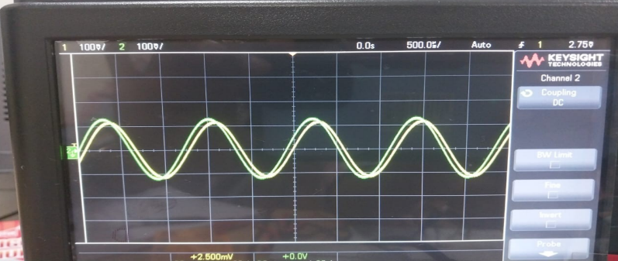

GREEN – V

YELLOW - VC

If frequency equal to cutoff frequency:

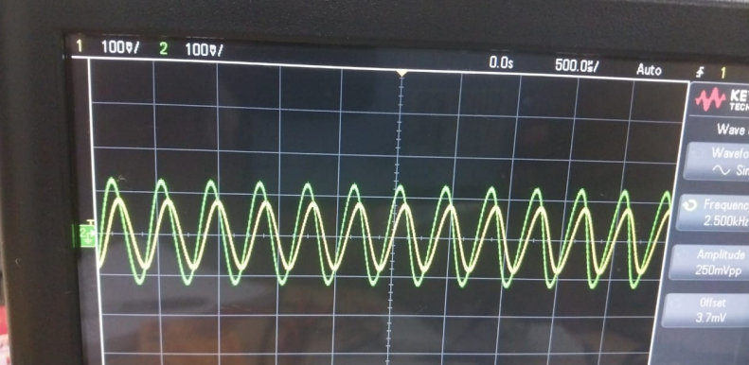

GREEN – V

YELLOW - VC

If frequency is greater than cutoff frequency:

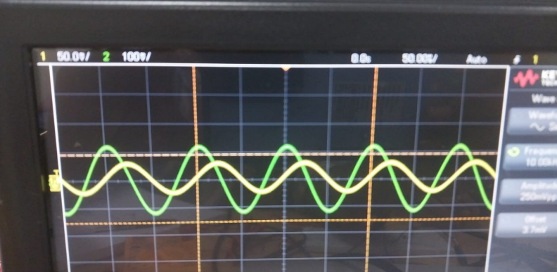

GREEN – V

YELLOW - VC

**Table with three different values of R and C:**

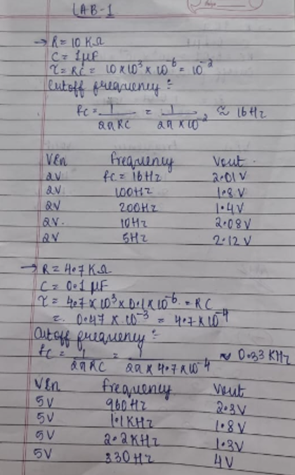

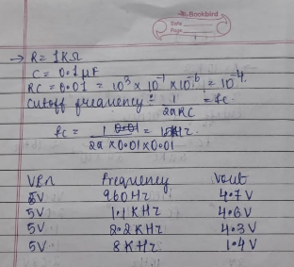

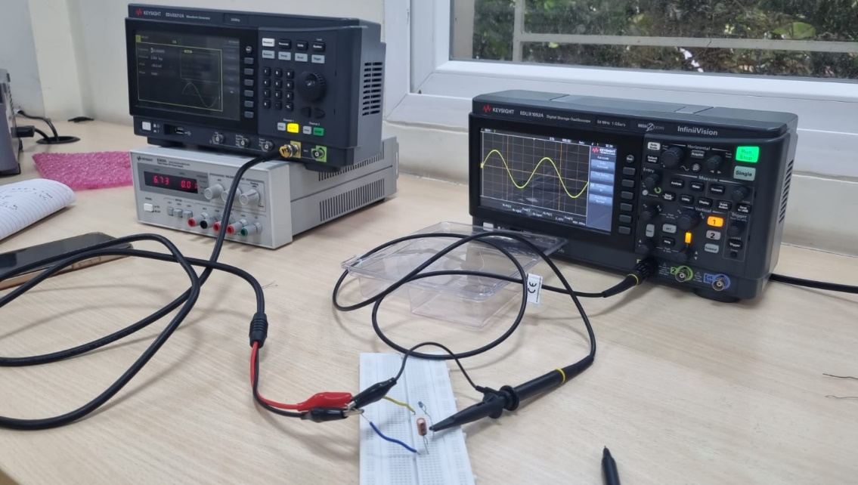

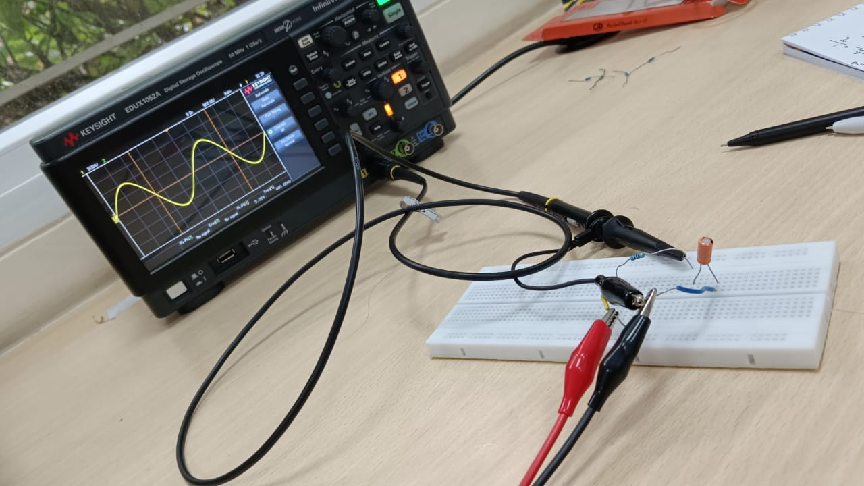

**Observations:**

Keeping Vin constant, voltage across the capacitor decreases for frequencies greater than the cut off frequency and voltage across the capacitor increases for the frequencies lesser than the cut off frequency.

**Reason:**

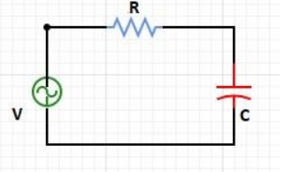

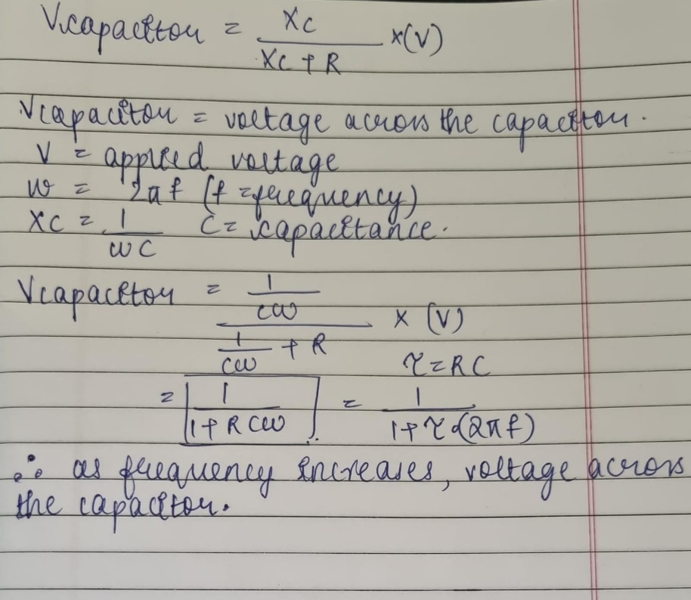

**Conclusion:**

For increasing values of frequencies, the voltage across capacitor decreases.

Voltage across the capacitor and input frequency are inversely proportional to each other.